VIRENDER KUMAR
Mobile No.: 09414512749
E-mail: kataria.virender2@gmail.com

~Mid Level Assignments~
~Financial Operations ~Sales & Marketing (Financial Products) ~Customer Relationship Management~

___________________Profile Snapshot___________________

- A competent professional with nearly 4 years of experience in:
Broker & Global Compliance Management Fund Management Problem Management
Profit Centre Operations Relationship Management Policy Management
Risk Management Product Management Liaison & Coordination
- Proficient in driving new business through key accounts and establishing strategic partnerships to increase revenue
- Experience in conceptualizing & implementing competitive strategies for generating sales, developing and expanding market share towards the achievement of revenue & profitability targets
- Excellent track record of evaluating the unit wise profitability and performing funds flow, debtors/ credit control and the product wise cost benefit analysis
- Capability to investigate all available sources of credit & financial information; experience in analyzing the financial statements and related material
- Consistent record of delivering results in growth, revenue, operational performance and profitability
- Aggressive sales & marketing tactics with strong exposure of working with prominent and high profile accounts
- Expertise in identifying strategies, processes & policies on dealer inventory funding & credit risk
- Innovative and results-driven manager focused on achieving exceptional results in highly competitive environments that demand continuous improvement
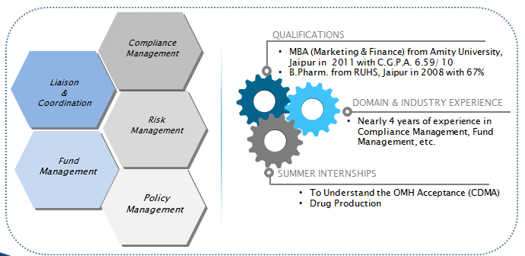
_________________Core Competencies___________________

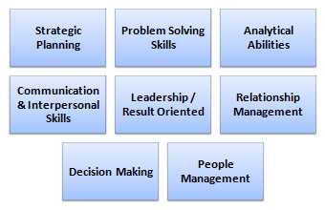
- Developing, designing and implementing fraud/risk management & fraud analytic projects to reduce/prevent losses and ensure compliance with regulatory environment
- Responsible for developing cases and collecting requirements for selected compliance solutions
- Suggesting & incorporating policy changes and reviewing their impact on the product portfolio
- Meeting product/ sales managers to discuss and evaluating impact of the proposed changes in the policy
- Evaluating and transcribing all consulting activities to include original issues, control concerns, work flow changes, policy & procedure updates and communication approach
- Monitoring the implementation of action plans to address key risk indicators reported monthly to risk management
- Planning and implementing the dealer schemes to achieve the business objectives
- Involved in Financial & Accounting Reconciliation, Customer Relationship Management & Cash Flow Management
- Scrutinizing the funds flow, collections & cash flow management and siphoning of funds & recommending measures

___________________Work Experience___________________
Since Jul’11 till Oct 14 with Kotak Mahindra Bank, Jaipur as Deputy Manager (Retail Asset Operations)

Key Result Areas:
- Responsible for redressing various queries of clients by understanding their problems related to loan accounts
- Involved in NOC issuance activities and processing the same
- Looking after the distribution of policies/ insurance certificates internally & externally in given time frame
- Overseeing collection & finalization of details for policy renewals
- Submitting details for renewal to brokers
- Verifying contractor compliances with respect to insurance and ensuring seamless coverage across the entire work/ contracting chain
- Managing disbursement of Commercial Vehicle, PL, BL, SPL, HF, LAP, TFE, AF , Saral and Construction Equipment
- Working as a Branch FPR for disbursement-C Scheme, Jaipur
- Ensuring that the risk report incorporates all the best practices and is mutually acceptable
- Discussing, clarifying and negotiating with brokers/ underwriters

Highlights:
- Efficiently maintained 98%+ accuracy in audit
- Effectively handled Jodhpur Location as Branch FPR for smooth execution of operations

___________________Summer Internships___________________
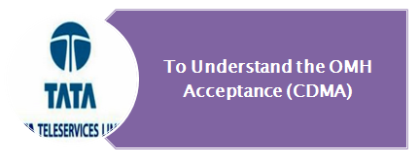
Title: To Understand the OMH Acceptance (CDMA)
Organization: Tata Teleservices, Jaipur
Duration: 8 weeks

Highlight:
- Awarded with Appreciation Certificate

Title: Drug Production
Organization: Elcon Drugs & Formulations Limited, Jaipur
Duration: 2 months

___________________Education___________________

- MBA (Marketing & Finance) from Amity University, Jaipur in 2011 with C.G.P.A. 6.59/ 10
- B.Pharm. from RUHS, Jaipur in 2008 with 67%
- 12th from B.S.E.R., Ajmer in 2002 with 69%
- 10th from B.S.E.R., Ajmer in 2000 with 75%

IT Skills: Well versed with MS-Office and Internet Applications

___________________Extramural Engagement___________________
- Actively took part in escorting of key note speakers during ‘International Psychology Conference’ at Amity
University, Rajasthan in Aug’10

___________________Personal Details___________________
Date of Birth : 3rd September 1985
Address: S/o Sh. Surender Mohan Kataria, E-2/199, Sector 2, Chitrakoot Scheme, Vaishali Nagar, Jaipur-302021, Rajasthan
Languages Known: Hindi, English, French and Punjabi
Location Preference: Jaipur/ North India

